Tab 1

# Passaporti 🛂

Fodler: <https://drive.google.com/drive/u/0/folders/1Y5qL62SYvms0Qv_JKKXehZsQzH4GschW>

* Alessandro Italiano 2025
* Sebastian Italiano 2025
* Riccardo Italiano
* Kate UK
  + **Katherine Elizabeth Carlesso-Knight**
  + **GBR**
  + **23may23 -> 23may33**
* Alessandro UK 2025
  + GBR ..
  + **10oct22 -> 10oct27**
* Sebastian UK 2025:
  + **GBR 149535460**
  + **15nov 24 -> 15nov29**

## Kate UK 2023

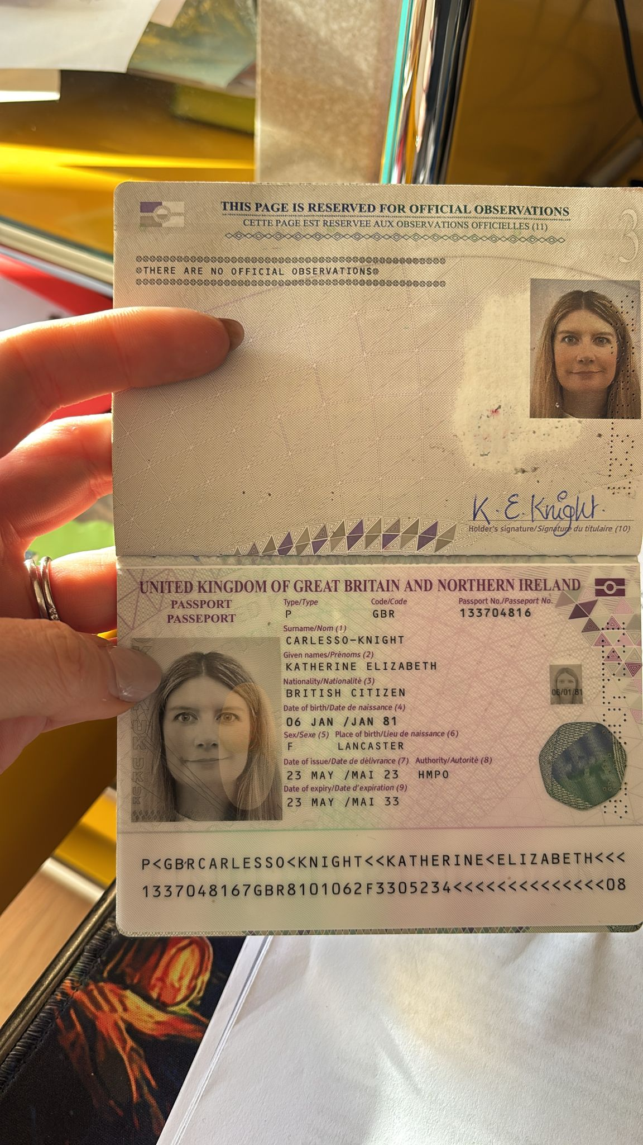

## Ale UK 2024

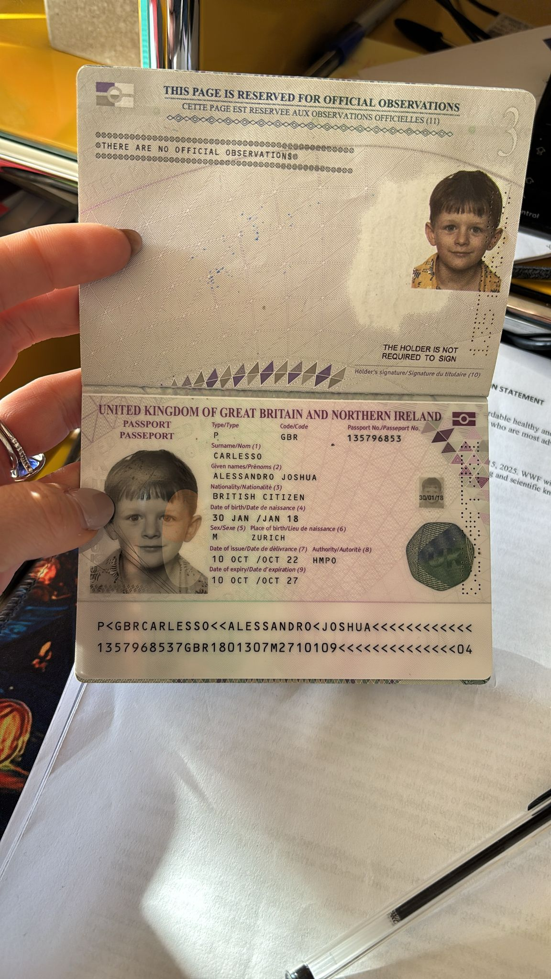

## Seby UK 2024

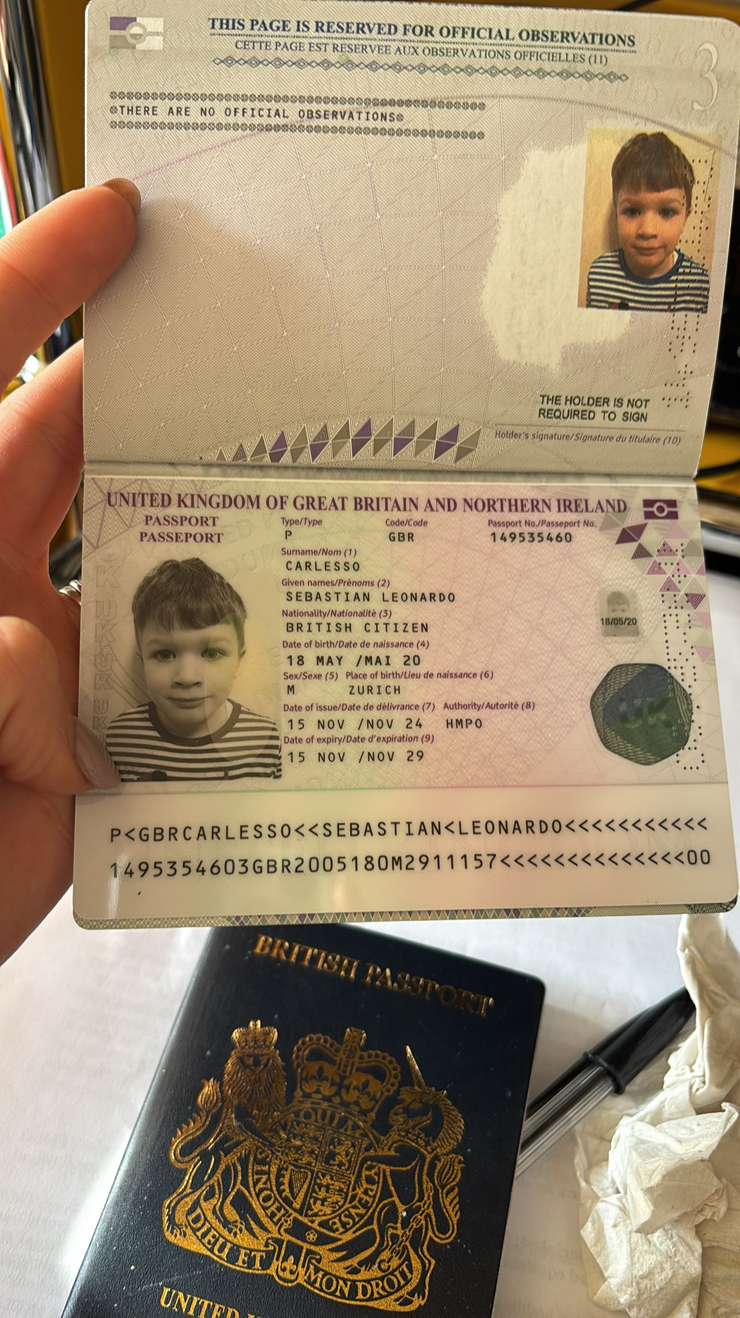

Images